**TO SUPPLY LEFTOVER FOOD TO POOR**

**COLLEGE NAME: KG COLLEGE OF ARTS AND SCIENCE COLLEGE CODE:**

**TEAM ID: NM2025TMID23727**

# TEAM LEADER:JAMRUTH ROSHINA

# **EMAIL ID: 2326ka**1**7@kgcas.com**

# TEAM MEMBER: JANANI K

**EMAIL ID: 2326Ka28@kgcas.com**

# TEAM MEMBER: JAYA SURYA H

# **EMAIL ID: 2326Ka19@kgcas.com**

# TEAM MEMBER: KANISHKUMAR V

**EMAIL ID: 2326ka20@kgcas.com**

# 1.INTRODUCTION

## 1.1PROJECT OVERVIEW

The Leftover Food Supply Management System is a Salesforce-based application designed to facilitate the efficient collection and distribution of surplus food to underserved communities. It connects donors with drop-off points and volunteers to ensure timely and hygienic delivery. The system is built to streamline key operations such as donor registration, volunteer task assignment, and delivery tracking. To enhance efficiency and accountability, the application utilizes Salesforce automation tools like Flows, Approval Processes, and Email Alerts.

## 1.2PURPOSE

The primary goal of this project is to empower organizations to efficiently manage the collection and distribution of surplus food. The system aims to reduce manual effort, improve the accuracy of tracking, and ensure timely coordination among donors, volunteers, and drop-off points.

Of course, Hem. Here is a structured outline for a document on a "Leftover Food Supply Management System," including the sections you requested for the beginning and the end.

## 1.3PROBLEM STATEMENT

The core problem is the inefficient and unorganized management of surplus food. Key challenges include:

* **LACK OF REAL-TIME INFORMATION:** Food donors (e.g., restaurants) have no immediate way to communicate the availability of surplus food to potential recipients (e.g., NGOs, shelters).
* **LOGISTICAL HURDLES:** There is no coordinated system for the timely pickup and delivery of perishable food, leading to spoilage.
* **FOOD SAFETY AND QUALITY CONCERNS:** Recipients have concerns about the safety and hygiene of leftover food, and donors fear liability issues.
* **SCALABILITY ISSUES:** Existing manual efforts by individual organizations are often limited in their geographical reach and cannot scale effectively to meet the demand.
* **DATA AND ANALYTICS GAP:** There is a lack of data on food waste hotspots, donation patterns, and demand, which prevents strategic planning and optimization.

# DEVELOPMENT PHASE

**Creating Developer Account:**

**By using this URL -** [**https://www.salesforce.com/form/developer-signup/?d=pb**](https://www.salesforce.com/form/developer-signup/?d=pb)

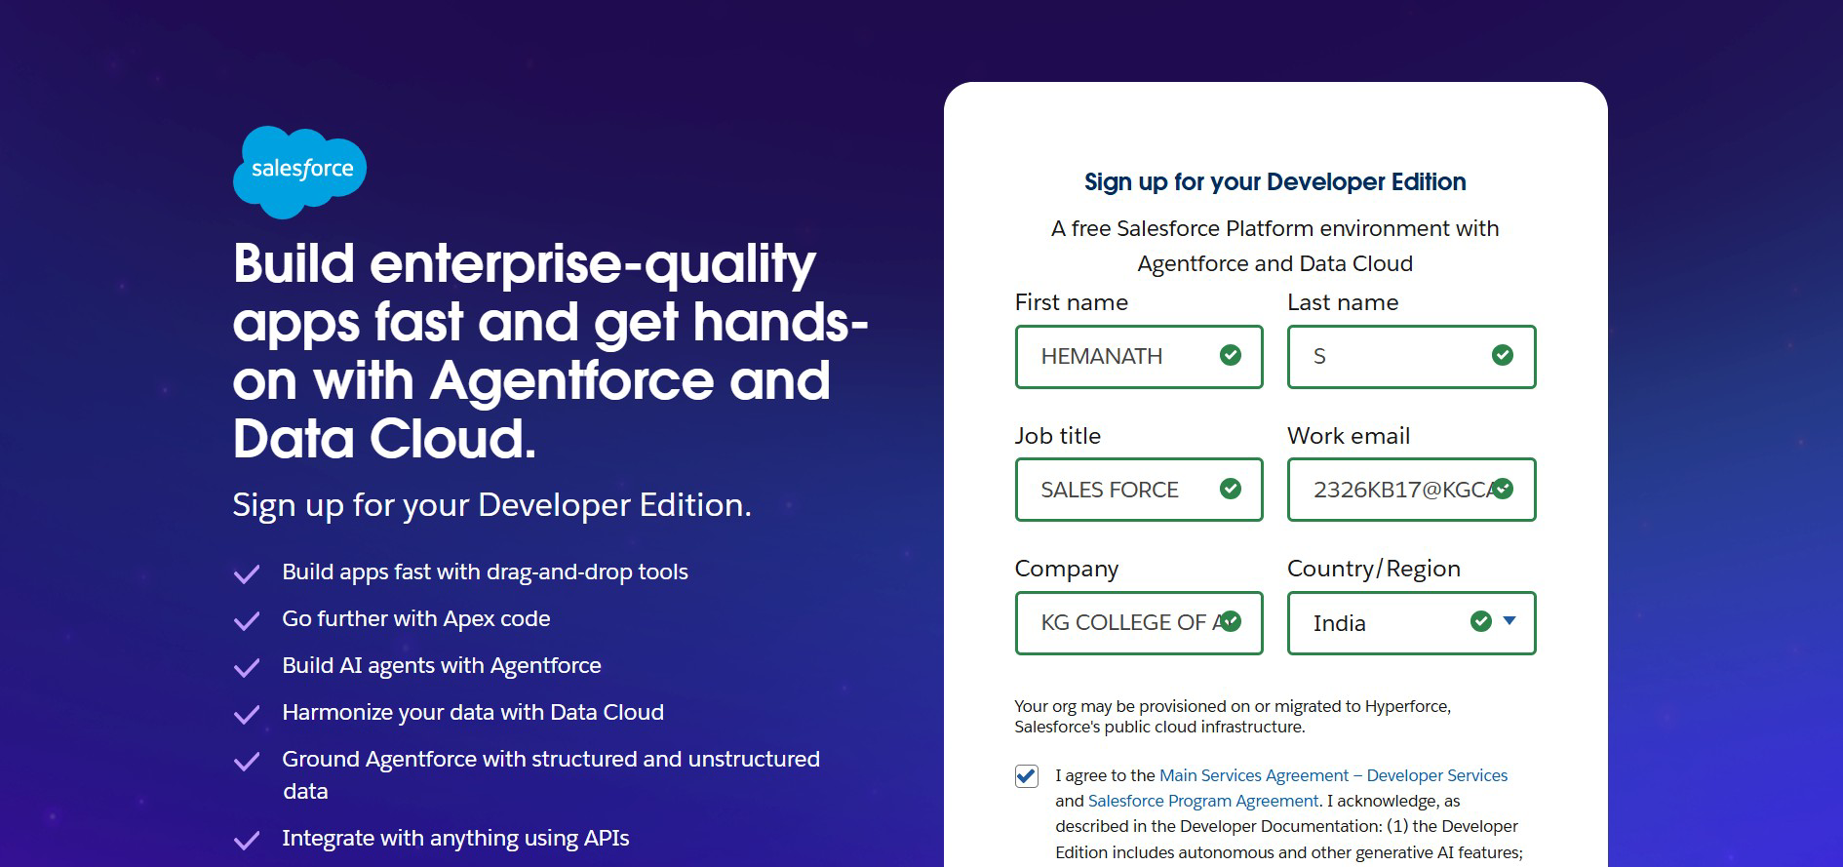

**Created objects: venue drop off point task volunteer execution details:**

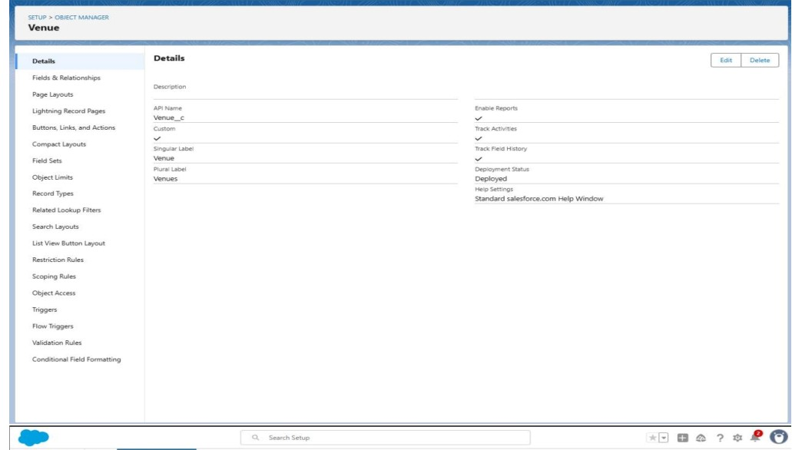

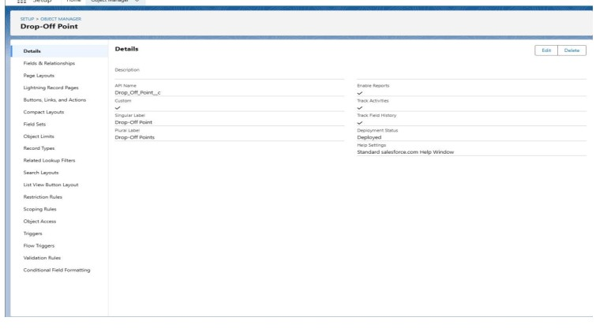

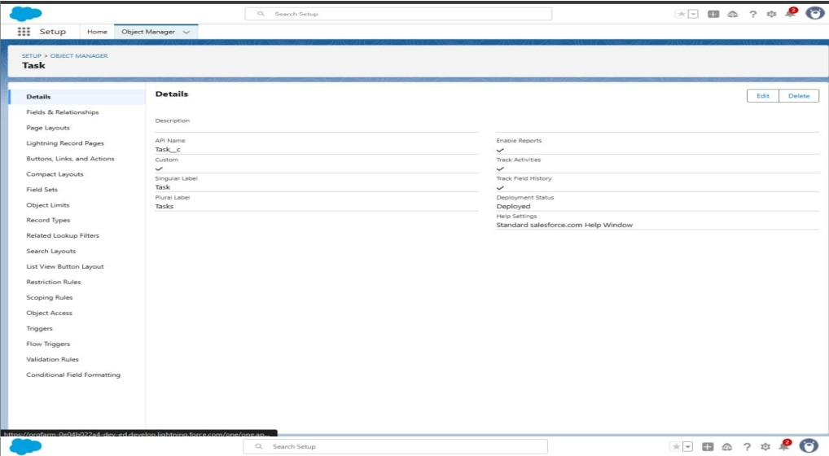

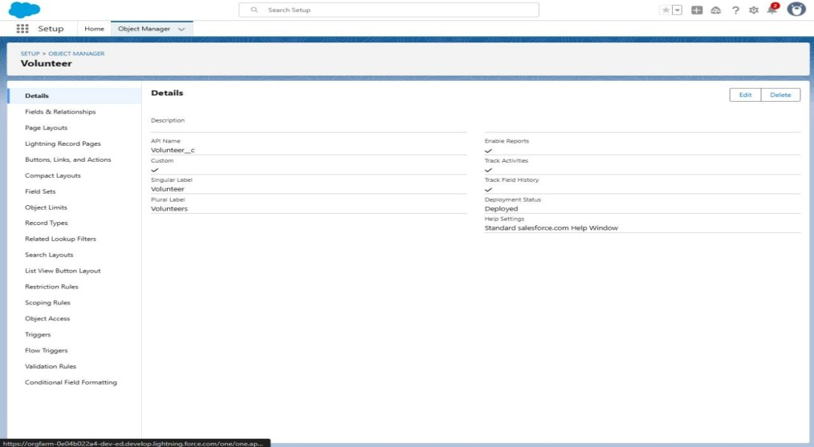

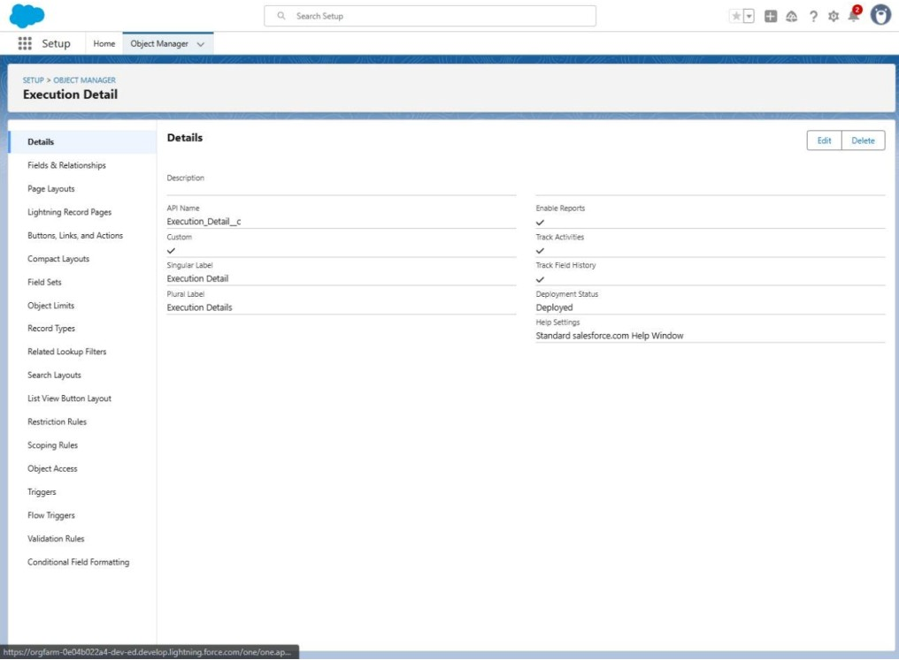

**Configured fields and relationships**

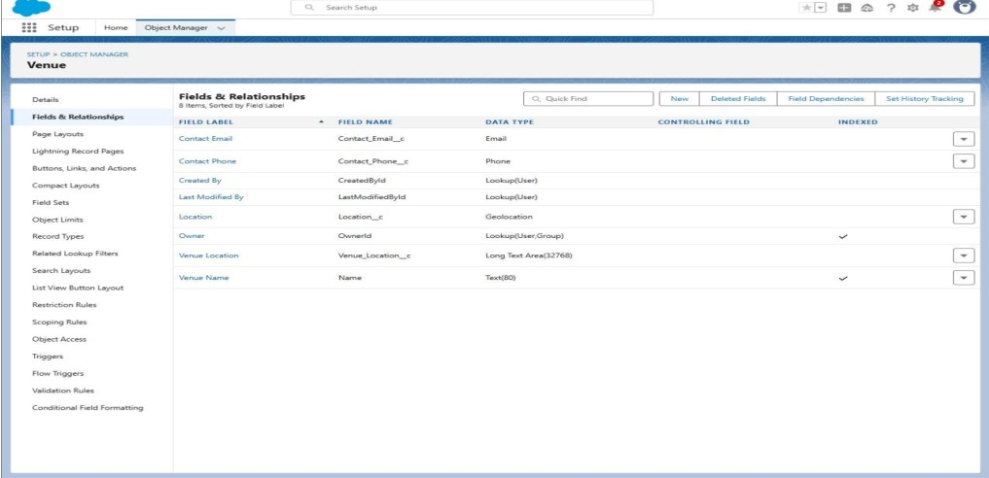

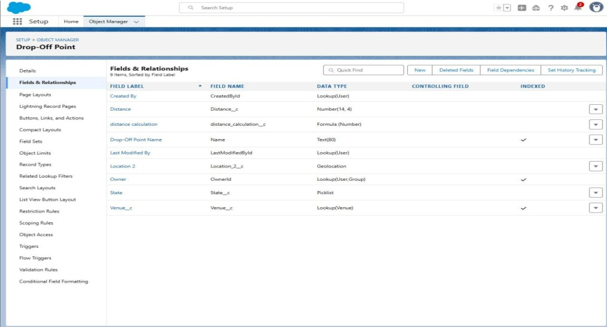

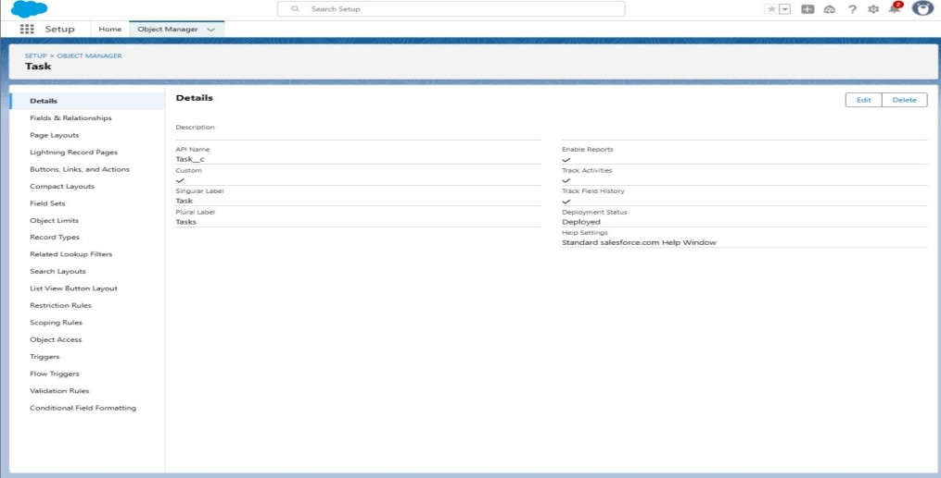

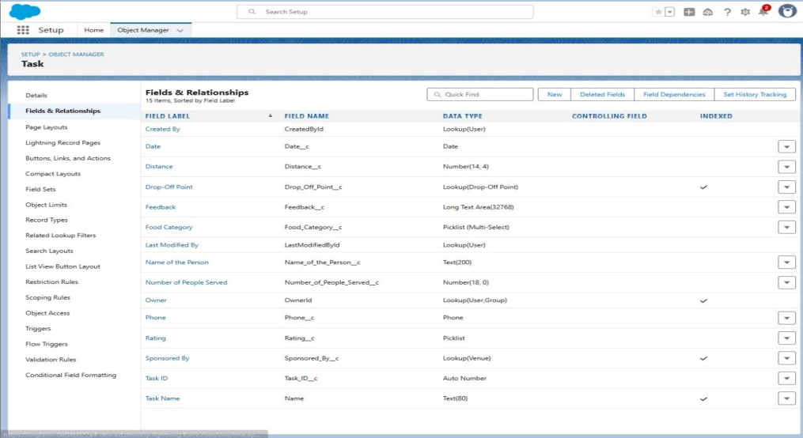

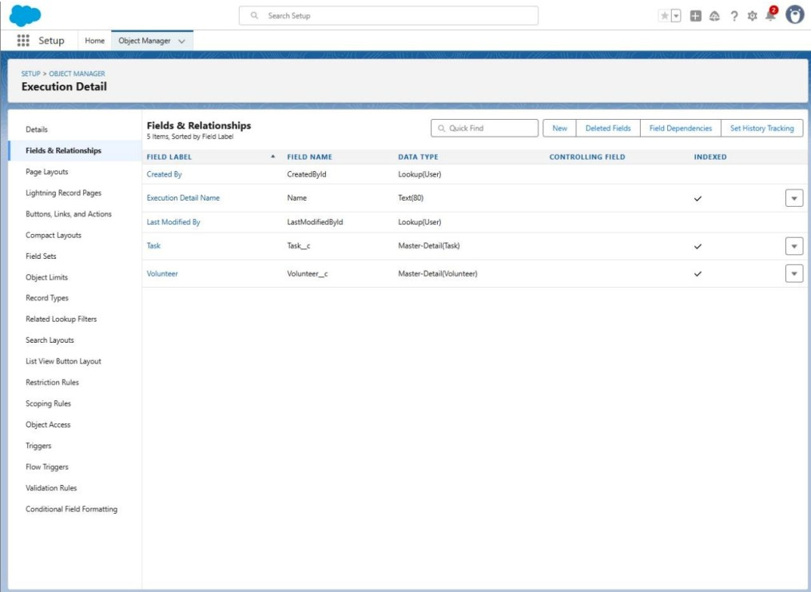

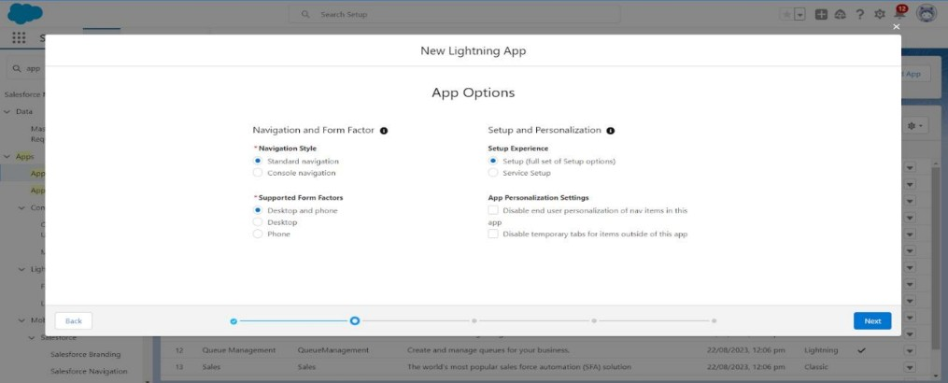

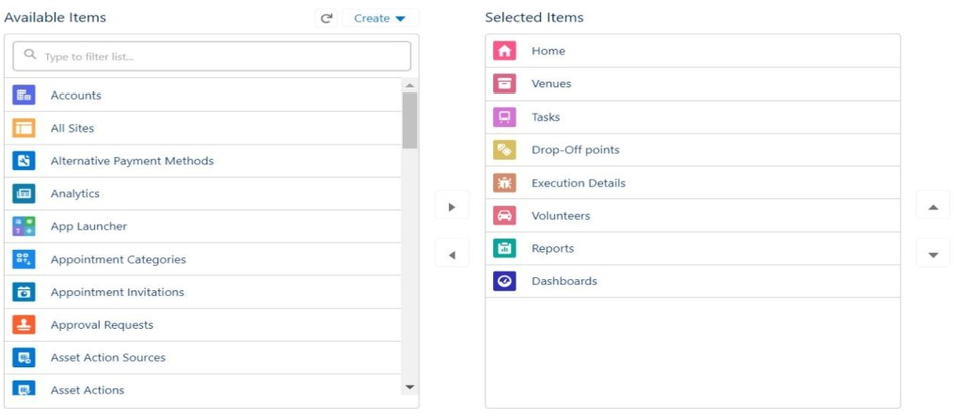

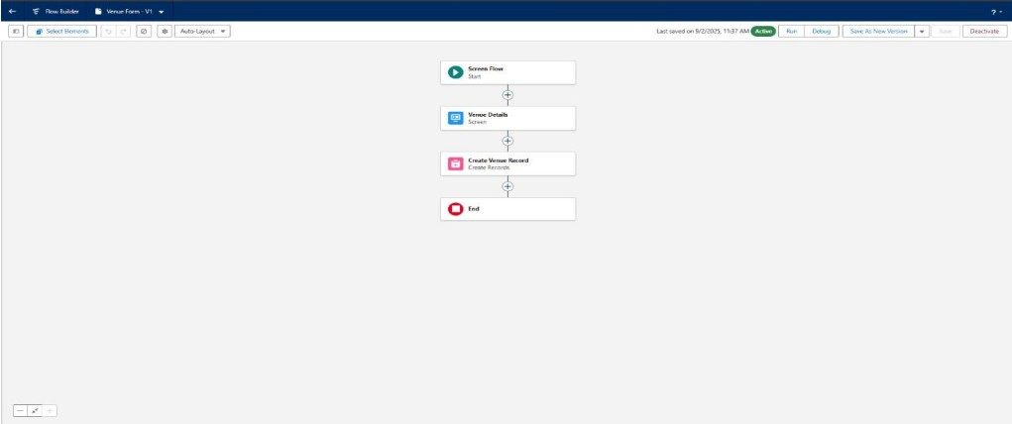

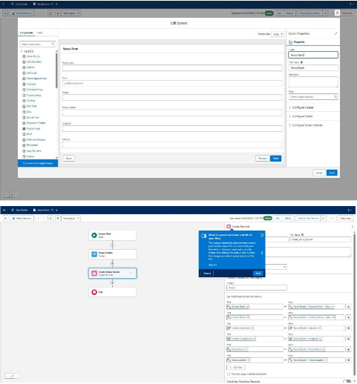

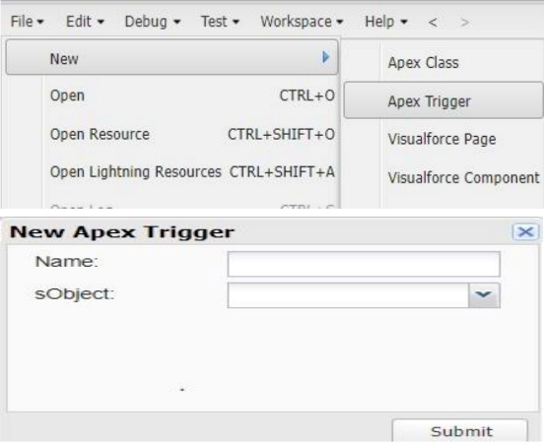

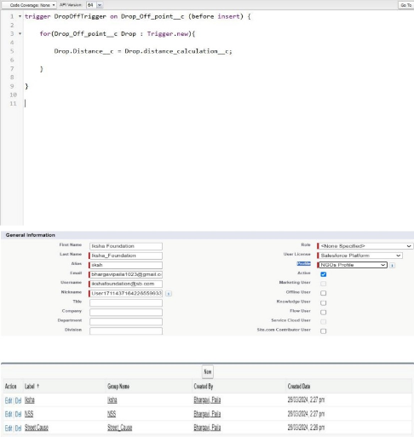

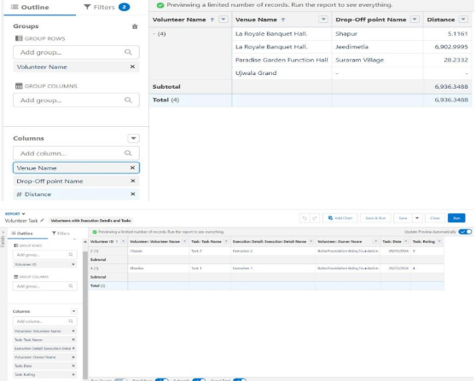

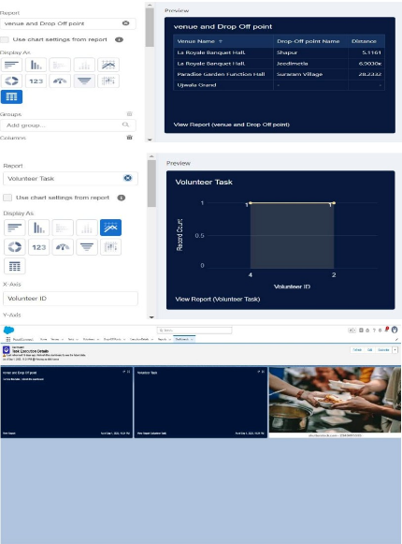

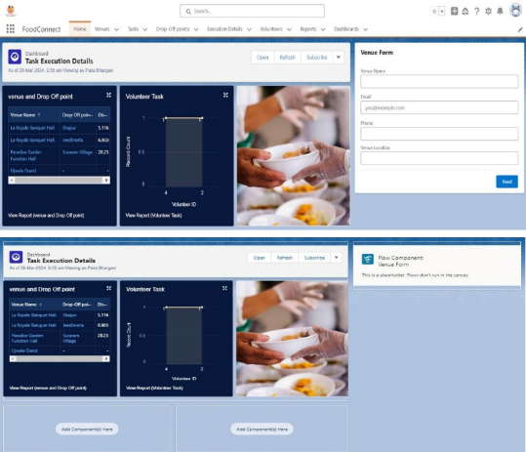

**FUTURE SCOPE OF THE LEFTOVER FOOD SUPPLY MANAGEMENT SYSTEM:**

The system will evolve beyond its initial donor-to-NGO model by leveraging AI for intelligent, predictive logistics, forecasting food surpluses, and optimizing distribution routes. The ecosystem will expand significantly to include the entire supply chain, from farmers at the source to individual households at consumption. Critically, the platform will integrate with corporate CSR programs by providing verifiable impact data, and with municipal bodies to inform waste management policies. This transforms it from a simple rescue app into a vital piece of civic infrastructure, building a truly sustainable and circular economy for the community.

## ADVANTAGES AND DISADVANTAGES

**ADVANTAGES:**

* **SOCIAL IMPACT:** Directly addresses hunger and malnutrition by redirecting surplus food to those in need.
* **ENVIRONMENTAL BENEFITS:** Significantly reduces food waste in

landfills, which in turn lowers methane gas emissions, a potent greenhouse gas.

* **ECONOMIC BENEFITS:** Donors save money on waste disposal fees.

Recipients reduce their food procurement costs.

### ● EFFICIENCY AND SCALABILITY: Automates the matching and

logistics process, making it far more efficient and scalable than manual methods.

**DISADVANTAGES:**

* **FOOD SAFETY AND LIABILITY:** The primary risk. Ensuring the

donated food is safe for consumption is a major challenge. A single incident could damage the platform's reputation.

* **LOGISTICAL COMPLEXITY:** Coordinating timely pickups and deliveries for perishable goods is complex and can be costly.
* **TECHNOLOGY ADOPTION:** Both donors and smaller NGOs may be hesitant or lack the resources to adopt a new technology platform.
* **INCONSISTENT SUPPLY:** The availability of surplus food can be

unpredictable, making it difficult for recipients to rely on it as a primary source.

* **INITIAL INVESTMENT COST:** Developing, launching, and maintaining the technology platform requires significant initial funding.

## CONCLUSION

The Leftover Food Supply Management System presents a powerful, technology-driven solution to the twin problems of food waste and hunger. By creating a transparent and efficient ecosystem, it connects the dots between surplus and scarcity. While challenges related to food safety, logistics, and user adoption exist, they can be mitigated through robust protocols, strategic partnerships, and a user-centric design. The potential social, environmental, and economic benefits overwhelmingly justify the endeavor. This system is not just about managing waste; it is about creating value, fostering community resilience, and ensuring that good food nourishes people, not landfills.

## APPENDIX

● Source Code: Provided in Apex Classes and Triggers trigger

DropOffTrigger on Drop_Off_point__c (before insert)

{

for (Drop_Off_point__c Drop: Trigger.new)

{

Drop.Distance_c = Drop.distance_calculation_c;

}